DBEDT Production Tax Credit Hub

Hawaii Film Office  
250 S Hotel St, Room 510  
Honolulu, Hawaii 96813

|  |  |
| --- | --- |
|  |  |

Table of Contents

Introduction ..................................................................................................................................................... 4

Process .............................................................................................................................................................. 5

Creating ehawaii.gov Accounts .............................................................................................................. 6

New Online Applicants Dashboard ........................................................................................................ 7

Pre-Production Registration Forms (PRF) Statuses ...................................................................... 8

Starting a New PRF Application ............................................................................................................ 10

1) Production Information ....................................................................................................... 14

2) Filing Entity Information ...................................................................................................... 15

3) Type of Production .................................................................................................................. 16

4) Local Production Office .......................................................................................................... 17

5) Production Synopsis/Script Upload ................................................................................. 17

6) Target Release Date and Distribution Plan ................................................................... 17

7) Target Hawaii Production Dates ........................................................................................ 18

8) Estimated Budget ...................................................................................................................... 19

9) Mandatory Workforce Development Contribution .................................................... 20

10) Hawaii Target Hiring Plan ................................................................................................... 21

11) Additional Requirements for claiming the Production Tax Credit .................... 22

12) Confidentiality Request ........................................................................................................ 23

13) Signature ..................................................................................................................................... 24

14) Review & Finalize .................................................................................................................... 25

Hawaii Production Report (HPR) ............................................................................................................ 28

Hawaii Production Reports (HPR) Statuses ....................................................................................... 29

Submitting a Hawaii Production Reports (HPR)............................................................................... 30

1) Production Information .......................................................................................................... 31

2) Filing Entity Information ....................................................................................................... 31

3) Type of Production ................................................................................................................... 31

4) Production Entity ...................................................................................................................... 31

5) Verification Review/CPA ........................................................................................................ 31

6) Release Date and Distribution Plan .................................................................................... 32

7) Hawaii Production Dates ......................................................................................................... 33

8) Expenditure Breakdown .......................................................................................................... 33

9) Hawaii Qualified Expenditures by Category ................................................................... 34

10) Payroll – Amount by Category ............................................................................................ 35

11) Hiring Report .............................................................................................................................. 36

11) Hiring Report (cont.) ............................................................................................................... 37

12) Workforce Development Contribution Report ............................................................ 38

13) Additional Requirements for claiming the Production Tax Credit ...................... 39

14) Confidentiality Request .......................................................................................................... 40

15) Signature ....................................................................................................................................... 40

16) Review & Finalize ...................................................................................................................... 40

Saving and Resuming Editing HPR ............................................................................................................ 41

Fees and Payment……………………… ............................................................................................................ 42

Certifications……...……………………… ............................................................................................................ 43

Introduction

Purpose

The purpose of this document is to assist Productions who seek to film in Hawaii to have their productions reported and taxed by the Hawaii Film Office.

Access

Users can use existing ehawaii.gov accounts or create a new account. No additional permissions are required to submit an application.

Process

Pre-Application

1. New Productions will go to <https://dbedtfilmtaxcredit.ehawaii.gov/> to have their productions documented and submitted to the Hawaii Film Office for handling.
2. Productions can then login with their eHawaii.gov accounts or create one as needed via [**Lala Account Creation**](https://login.ehawaii.gov/lala/account/new.lala?lalaSignUp=true&onCompleteUri=https%3a%2f%2fdbedtfilmtaxcredit.ehawaii.gov&returnName=Production+Tax+Credit+Hub&returnUri=https%3a%2f%2fdbedtfilmtaxcredit.ehawaii.gov).
3. After logging in, the user will be shown the DBEDT Production Tax Credit Hub Dashboard where they have access to all functions needed to submit their production(s).

Application

1. From the dashboard, users can start a new application for Pre-Production Registration Form (PRF).
2. After filling out all sections and providing all applicable information. Users can submit their PRF application to then be reviewed by DBEDT Administration.
3. If the application becomes approved by the DBEDT Administration, the status of the form becomes approved, and users can now begin the Hawaii Production Report (HPR) for the approved application.
4. Similarly, once the (HPR) is completed, users can submit this for approval.
5. Once the HPR is approved, payment will need to be made online before a certificate is issued.
6. Once the payment is submitted and certified, a certificate is issued for that production and the process is completed.

: Users can submit any number of PRF applications and any number of approved PRF applications can be submitted as an HPR.

Creating an ehawaii.gov (Lala) account

1. Go To [Lala Account Creation](https://login.ehawaii.gov/lala/account/new.lala?lalaSignUp=true&onCompleteUri=https%3a%2f%2fdbedtfilmtaxcredit.ehawaii.gov&returnName=Production+Tax+Credit+Hub&returnUri=https%3a%2f%2fdbedtfilmtaxcredit.ehawaii.gov)
2. Enter a valid email into the email field and click continue

1. The user will then be brought to the account creation form where various fields must be filled out.
   1. Fill out all required fields
   2. Ensure a strong password is used according to the password guidelines (Click on the question mark for more information)
   3. Agree to the Terms of Use
2. After the account is created you can now use this account to login to DBEDT to start the process

New Online Applicants Dashboard

After logging in, users will be brought to the DBEDT Dashboard where they can manage their account, Submit Pre-Production Registration Forms (PRF) and Hawaii Production Reports (HPR), and Certifications.

As a new applicant, this dashboard will have no entries.

Pre-Production Registration Forms (PRF) Statuses

Under the PRF section, users can view statuses, make edits, and perform other actions on any PRF applications that have been created by the user. Various statuses that can be seen are:

**Draft** – User has begun the PRF application but has not submitted it



* User can resume editing the application from a saved state
* User can withdraw application
* Draft will reach submitted status once the application has been completed and submitted

**Submitted** – User has submitted PRF application and awaits admin action



* User can view all contents of the submitted application
* User can download and print the application
* User can withdraw the application

**In Review** – Admin has begun review process of submitted PRF application



* User can view all contents of the submitted application
* User can download and print the application
* User can withdraw the application

**Approval – Pending SOPP**



* User can view all contents of the submitted application
* User can download and print the application
* User can upload SOPP
* User can withdraw the application

**Approval – Final** - User’s submitted PRF application has been approved by admin



* User can view approved application
* User can download and print the approved application
* User can download workforce (HPR) form
* User can withdraw the application
* This application now qualifies to be used in the Hawaii Production Reports (HPR) process

**Rejected** – Admin has rejected PRF application



* User can view rejected application
* User can download and print the rejection application
* User can withdraw the rejected application

**Withdrawn** – User has withdrawn a PRF application



* User can view the withdrawn application

Starting a New PRF Application

To start a new PRF Application, users must first login using an ehawaii.gov account from the home page.

After logging in and being directed to the DBEDT Dashboard, Click on the “Start a New Application” to begin the application process.

Once clicked, users will be directed to the application for the Production Tax Credit Pre-Production Registration Form. This form has 14 sections all of which must be filled out before the PRF Application can be submitted.

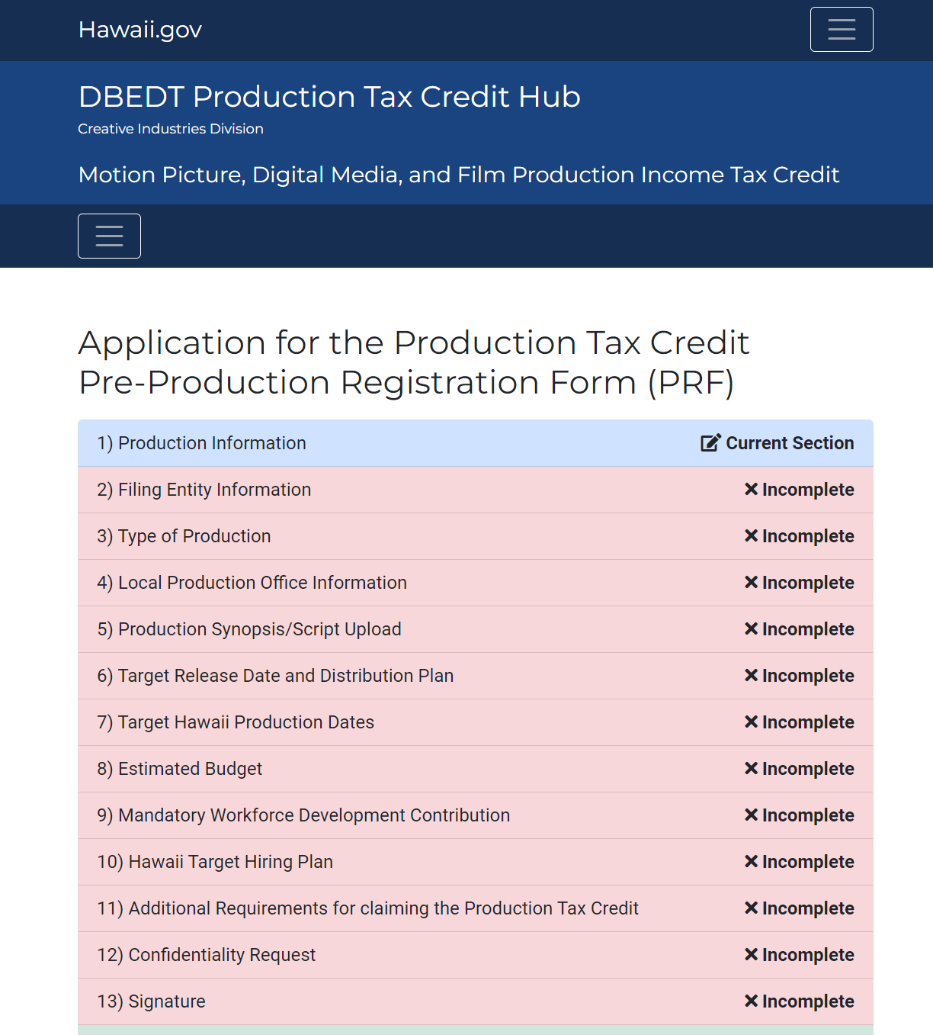

As more sections are completed, they will be marked as such. Users can move between completed sections by clicking on the blue links that appear after the section has been completed. The next uncompleted section can also be moved to.

**The Form Sections are as follows:**

1) Production Information

2) Filing Entity Information

3) Type of Production

4) Local Production Office

5) Production Synopsis/Script Upload

6) Target Release Date and Distribution Plan

7) Target Hawaii Production Dates

8) Estimated Budget

9) Mandatory Workforce Development Contribution

10) Hawaii Target Hiring Plan

11) Additional Requirements for claiming the Production Tax Credit

12) Confidentiality Request

13) Signature

14) Review & Finalize

1) Production Information

Production Information is a short section which marks the beginning of the PRF application. All fields shown are required.

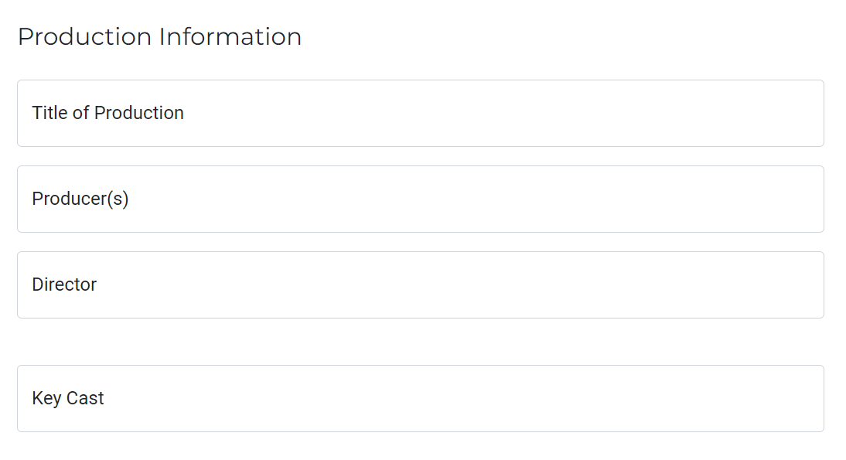

2) Filling Entity Information

In this section, users can upload Filing Entity Information. Fields of note include the Secondary Contact(s) and Registration Statuses of DCCA and DOTAX.

For Secondary Contact(s) it is not required to have one. When adding a secondary contact Title, Phone, and Email fields will need to be filled out before the section can be submitted.

When selecting Yes for either “Registered with DCCA” or Registered with DOTAX”, an upload field will appear which requires the submission of a file to prove registration for the respective organization. Leaving the sections set to No will not require file upload.

**Filing Entry Information Fields.**

|  |  |
| --- | --- |
| **Requires Fields** | **Optional Fields** |
| * Production Tax Year * Filing Entity Name * Tax Filing Designation   + Calendar Year Filer   + Fiscal Year Filer * Filing Year (Period) * Street * City * Country * Zip Code * Primary Contact - Point of Contact Name * Primary Contact - Point of Contact Title * Primary Contact – Phone * Primary Contact – Email * Entity Type * Federal ID * State Incorporated/Registered * Registered with DCCA?   + Yes/ No * Registered with DOTAX?   + Yes/ No | * State * Primary Contact – Fax * Secondary Contact(s)   + Secondary fields become required if secondary contact is added * General Excise Tax Number   **File Uploads**   * If Selected “Yes” for “Registered with DCCA?”   + (**Required**) Upload: DCCA – Certificate of Authority File(s) * If selected “Yes” for “Registered with DOTAX?”   + (**Required**) Upload: DOTAX: GET-LETTER ID File(s) |

3) Type of Production

Productions can declare their type of production from the types provided. For Feature Film, Short Film, or Streaming, there is an option to (but not required) to further specify the production.

4) Local Production Office Information

Within this section all fields except Fax and Website of Production are required.

Productions can also allow the Hawaii Film Office to publish local production office information on their website. Checking the box next to the type of information authorizes the film office to publish. This field is not required.

5) Production Synopsis/Script Upload

Productions are required to write a detailed Synopsis of Production as well as submit a script upload in PDF format with file size under 32 MB.

6) Target Release Date and Distribution Plan

Production must select one of the distribution plans before continuing. Target Release Date is not required but must be a valid date. Release Notes are also not required.

7) Target Hawaii Production Dates

The Production Year 1 field will automatically fill out depending on the Production Tax Year. Pre-Production, Shoot, Wrap, and Post dates must be filled along with the % Shot in Hawaii for the Shoot and Post fields.

If the “This is a multi-year production” box is checked. A field identical to the Year 1 Timeline appears and must be filled out in a similar manner.

If a Target Release Date was chosen in section 6) Target Release Date and Distribution Plan, all of the production dates must be before this date. If this is not the case, both sections 6) and 7) will display an error requesting that either the Target Release Date or offending production date be changed to resolve this conflict.

Preproduction dates must start before all other sections start dates. Besides these restrictions, production windows can overlap in their time windows.

8) Estimated Budget

Production can enter a total project budget and then declare what portions of this budget are being used for production in Hawaii. Oahu, Big Island, Maui, Kauai, Molokai, and Lanai are all islands which can have a budget dedicated to them. Additional islands not listed can be stated as well.

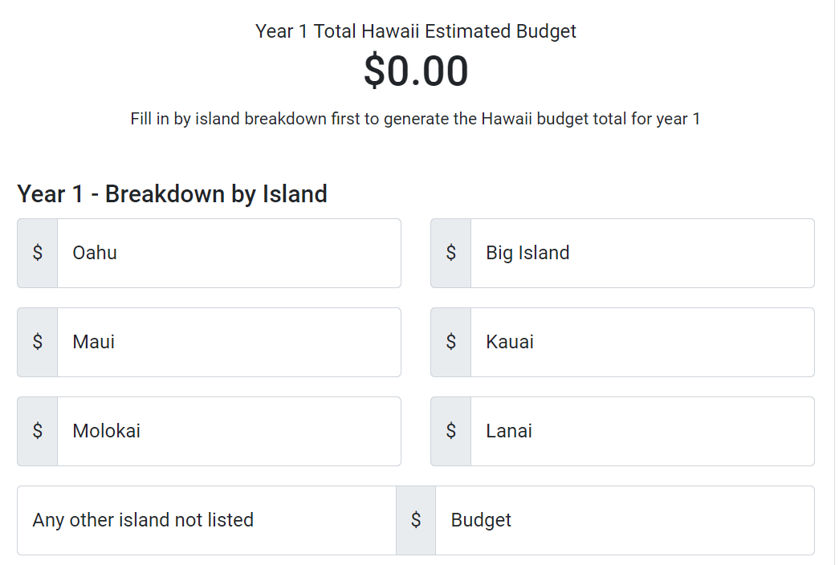

If the production is a multi-year production, the breakdown by island section will duplicate for each production year. Users can also upload an estimated budget breakdown. This is not required.

9) Mandatory Workforce Development Contribution

Production must declare types of Workforce Development contributions they plan to make. It is required that at least one Workforce Contribution is selected. If Other is selected, a description must be provided.

10) Hawaii Target Hiring Plan

In this section, Production can list out its hiring plan depending on the type of hires as well as the quantity of local and non-local hires for each position. If the form has been filled out as a multi-year production, hiring plans must be filled out for all years. If Other categories are added, a quantity must also be supplied.

Productions can also, list what efforts will be taken to hire Hawaii residents and applicable Unions in accordance with **(**[**HAR §18-253-17-16**](https://files.hawaii.gov/tax/legal/har/har_235.pdf)**):**. This is not required.

11) Additional Requirements for claiming the Production Tax Credit

In this section, Productions must understand and acknowledge all requirements in accordance with various policies (list policies?). All requirements must be acknowledged.

12) Additional Requirements for claiming the Production Tax Credit

In this section Production can choose to submit a Confidentiality Request on the application. If the “No information submitted on this application is subject to any confidentiality requirement” is selected, then the user can proceed to the next section. If Production wishes for information to be kept confidential, they can specify types of information that is wished to be omitted as well as an upload field for a Confidentiality Request Letter.

13) Signature

Production must sign the application with Name, Phone, Title, and Email. All fields are required.

14) Review & Finalize

Once all Application sections have been filled out, all information will be presented in this section. From here the user can view and edit any section to verify that all information entered and choices selected are accurate. Once the user verifies all of this, then they can submit the application at the bottom of the section.

Once the user submits the application, they will be directed back to the User Dashboard where they can now see the Application and current status under the PRF section.

Saving and Resuming Editing PRF

The PRF form can be saved at any time. There is a save button located near the submit and continue button in each section.

If the section is incompletely filled out or you wish to do it later, clicking save will move you forward to the next section and save all entered fields for that section.

If you leave the form and click the Resume button from your dashboard, all data up to the point where you last saved will be present. Edits done on an unsaved section will be lost.



Clicking on the “Resume” button will direct you to the application editing page where you can continue editing the form till completion.

Hawaii Production Report (HPR)

After a PRF application is approved, Productions can begin the process to submit it as a Hawaii Production Report (HPR). Many of the sections of the HPR transfer over from the PRF with a few additional sections that must be filled out.

**The forms sections are as follows:**

1) Production Information

2) Filing Entity Information

3) Type of Production

4) Production Entity

5) Verification Review/CPA

6) Release Date and Distribution Plan

7) Hawaii Production Dates

8) Expenditure Breakdown

9) Hawaii Qualified Expenditures by Category

10) Payroll - Amount by Category

11) Hiring Report

12) Workforce Development Contribution Report

13) Additional Requirements for claiming the Production Tax Credit

14) Confidentiality Request

15) Signature

16) Review & Finalize

Hawaii Production Reports (HPR) Statuses

HPR contains statuses that are identical to the PRF. However, HPR does not have all the statuses of the PRF application.

**Draft** – User has begun the PRF application but has not submitted it



* User can resume editing the application from a saved state
* User can withdraw the application
* Draft will reach submitted status once the application has been completed and submitted

**Submitted** – User has submitted PRF application and awaits admin action



* User can view all contents of the submitted application
* User can download and print the application
* User can withdraw the application

**Withdrawn** – User has withdrawn a PRF application



* User can view the withdrawn application

**In Review** – Application is in review by DBEDT



* User can view the application
* User can download and print the application

**Approved – Pending Payment of HFO Fee** – Application has been approved and waiting payment



* User can view the application
* User can download and print the application
* User can submit payment

**Approved – Pending Certification** – Application has been paid and awaiting certification



* User can view the application
* User can download and print the application

**Approved – Finalized – Certification Issued** – Certificate has been issued by DBEDT



* User can view the application
* User can download and print the application
* User can download the certificate under Certifications section

Starting a Hawaii Production Reports (HPR)

1) Production Information

The Production Information section is identical to the PRF application, and all text entered will automatically be entered in the field.

2) Filing Entity Information

All fields of the Filing Entity Information are identical to the PRF except for the addition of the Accounting Method. After making this selection this section will be fully filled out.

Note: When processing the second year HPR filing of a Multi-year production, attachments will need to be re-uploaded

3) Type of Production

The Type of Production section will prepopulate based on selections in the PRF. There are no additional fields.

4) Production Entity

Production Entity will be filled out using information supplied in the Local Production Office Information Section.

5) Verification Review/CPA

In this section productions can choose to submit proof of a Completed Verification Review/CPA. This can be done by choosing ”Yes” from the options and filling out all the fields that appear. A field for uploading proof of verification must also be completed. If “No” then no additional fields will appear and the user can move onto the next section.

Note: The second year HPR filing of a Multi-year production will begin here. Attachments will need to be re-uploaded as well.

6) Release Date and Distribution Plan

Target Release Date and Distribution Plan will be transferred from the PRF application. The “Shoot Locations” and “Problems Encountered/Solved” are two new fields. The “Shoot Locations” field must be filled out to be able to move on from this section.

7) Hawaii Production Dates

The Production Dates are completely transferred from the PRF. It will show all production stages inputted as well as show multiyear productions. If no changes to the Production Dates were made, this section can be submitted as is.

8) Expenditure Breakdown

The budget and breakdown by island will be transferred from the PRF application. In the HPR section, the Expenditure Breakdown must be uploaded. There are options for multiple expenditure breakdown to be uploaded but only one is required.

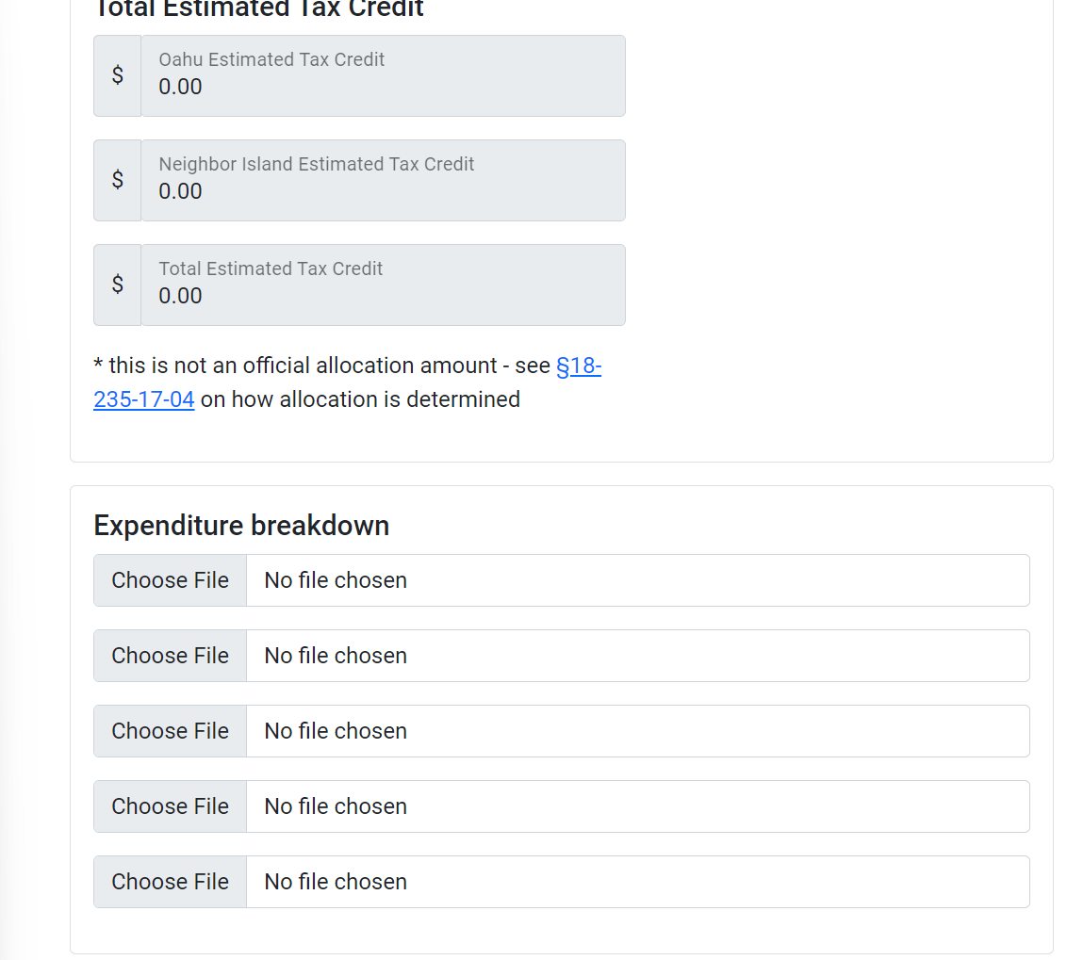

9) Hawaii Qualified Expenditures by Category

Productions can list out In/Out of State expenditures of the categories listed on the form. Sections include:

* Air Travel
* Construction
* Equipment Rentals
* Purchase of Materials
* Warehouse/Storage
* Business/Professional Service
* F&B/Catering
* Hotel/Accommodations
* Other

Options to upload expenditure detail backup files is provided.



* Please ensure that the payroll total matches the total amount of payroll in section 10.

10) Payroll – Amount by Category

Productions can list out Payroll for various Personnel (1099) ATL/BTL and Personnel (W-2) ATL/BTL. Hawaii Residents and Non-residents must be accounted for. If the production is a multi-year production payroll for all years can be filled out.

* Please ensure the total amount of payroll matches the payroll total in section 9.

Option to upload related payroll backup detail is provided as well. Payroll

11) Hiring Report

This section transfers over Hawaii and Non-Resident hiring numbers from the PRF application. Productions must account for every hire by listing the number of Hawaii Resident and Non-Residents are working at any particular role. The total number of hires must match the total number of Hires by Department.

The Hawaii Resident vs. Non-Resident Hires by category is transferred.

Assuming no changes to the initial hiring amount has changed, production can begin to list their hires by department account for Hawaii vs. Non-Resident quantities.

11) Hiring Report (cont.)

The totals listed under the Hawaii Resident vs. Non-Resident Hires by Department must match that of the section above.

After accounting for all hires by department. Productions must account for all Hawaii Resident Hires by County Residency. Once this is done the section is complete.

12) Workforce Development Contribution Report

Productions will detail their workforce contributions by first selecting the method of workforce contribution they have chosen to do.

Depending on the Type(s) of Contribution(s) selected, additional fields will appear which will be required before the submission of this section. Selecting options within these sections can also produce more fields to be completed. For example,

Selecting the “In-kind donation…” option will provide additional fields to detail what equipment or goods will be donated. Selecting said good will then prompt the detailing of what is being provided.

13) Additional Requirements for claiming the Production Tax Credit

Productions will need to Acknowledge the Tax Advisory Notices via [HAR §18-235-17-18](https://files.hawaii.gov/tax/legal/har/har_235.pdf).

Production will also have the option to upload additional documentation.

When an option is selected, a field for file upload will appear. If an option is selected, a file must be uploaded moving to the next section.

14) Confidentiality Request

This section is identical to the Confidentiality Request section featured in the PRF section of the form. If certain information is chosen to be made confidential, then the production must specify and upload a Confidentiality Request letter. If no request is needed, then users can move onto the next section.

15) Signature

This section is required to be filled out to submit the HPR application. This information will appear on the Certification provided after the HPR application is approved.

16) Review & Finalize

Productions can view all sections and verify that all information provided is accurate. Once done, users can click “Submit Application” to submit their HPR application.

Saving and Resuming Editing HPR

The HPR form can be saved at any time. The process and functionality are identical to that of the PRF section.

If the section is incompletely filled out or you wish to do it later, clicking save will move you forward to the next section and save all entered fields for that section.

If you leave the form and click the Resume button from your dashboard, all data up to the point where you last saved will be present. Edits done on an unsaved section will be lost.



Clicking on the “Resume” button will direct you to the application editing page where you can continue editing the form till completion.

Fees and Payment

Each taxpayer claiming a tax credit under this section shall submit to the Department of Business, Economic Development, and Tourism a fee for the motion picture, digital media, and film production income tax credit in an amount equal to 0.2 percent of the tax credit claimed by the qualified production no later than the deadline stated in subsection (c). See sub-section (k) [HRS 234-17](https://www.capitol.hawaii.gov/hrscurrent/vol04_ch0201-0257/hrs0235/hrs_0235-0017.htm).

Payment can be submitted online at the DBEDT Dashboard next to the respective approved production.

Certification

The Certificate can be downloaded and printed once payment has been completed and DBEDT has certified and uploaded your Certificate.

The Certificate can be downloaded under the Certification section of the dashboard.

